# Find the Last ID of Leaving a Round Table

Assume there are **n** students who seat in the circle/round table. Each student is associated with an ID by order of the circle. An example with **n=11** is shown below.

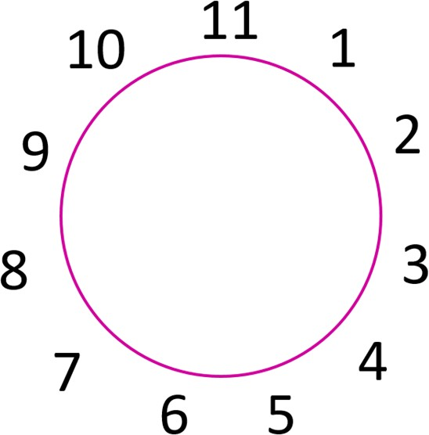

Now the teacher askes these students to report the numbers 1, 2, and 3 repeatedly (1, 2, 3, 1, 2, 3, 1, 2, 3, ...) from student ID 1 in an ascending order. Students who report 3 is required to leave the table. Your task is to write a program that can allow the user to input the total number of students (**n**), and output the student ID who is the last one seating on the round table.

## Sample Input/Output: